**Ex 15-1 # 1&2:**

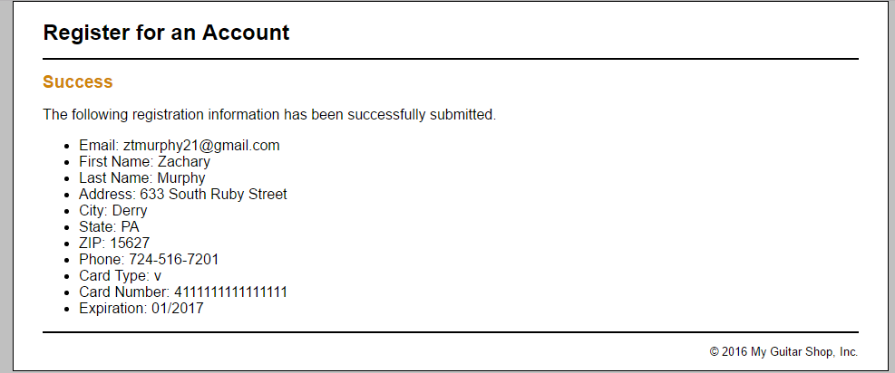

I can test and run the application by entering valid data.

**Ex 15-1 #3:**

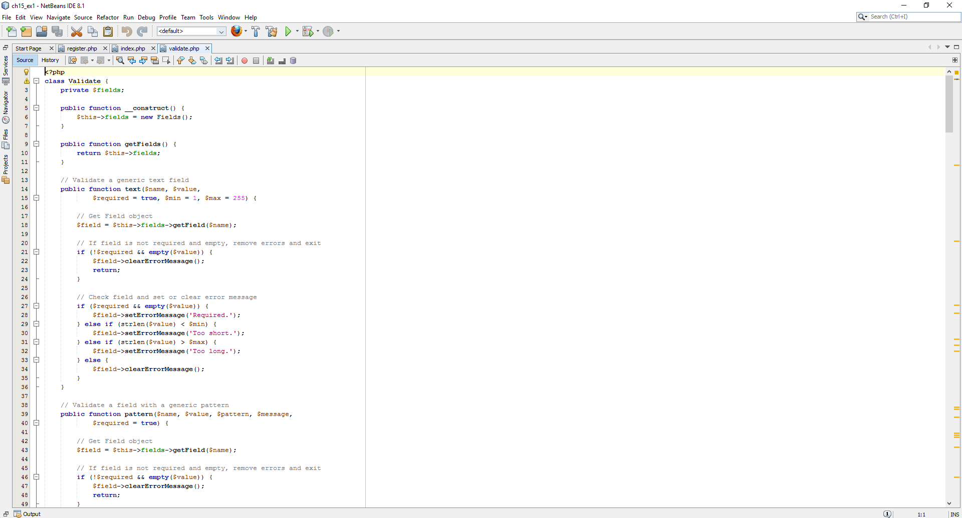

Opened index.php, validate.php, and register.php in NetBeans to review the code.

**Ex 15-1 #4:**

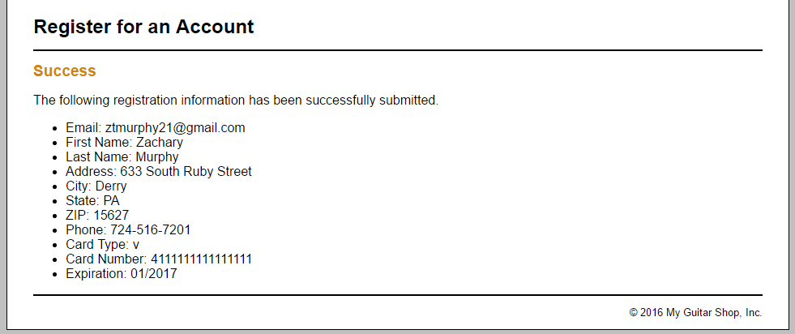

Changed the patterns as indicated and program still works.

**Ex 15-1 # 5:**

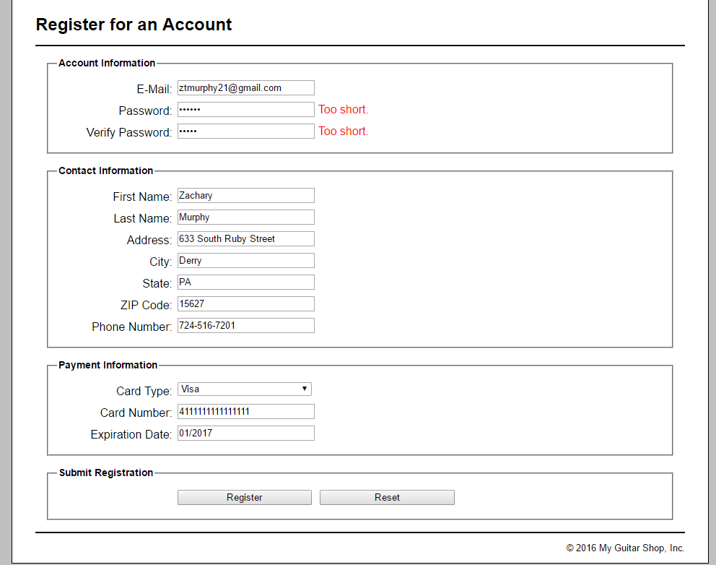

Requires eight characters.

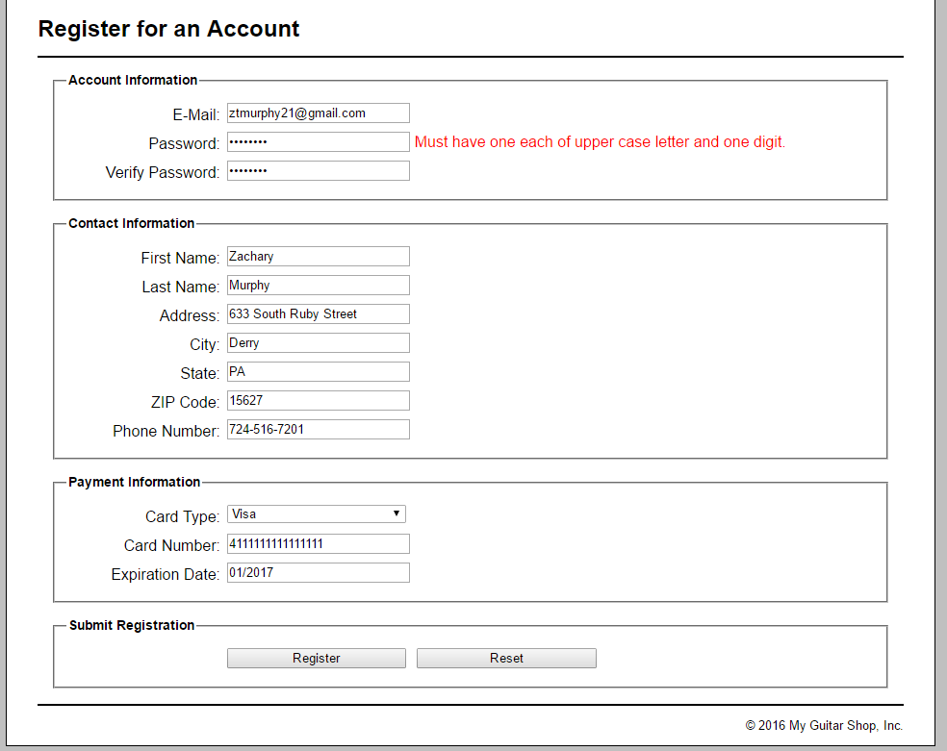

Also, only requiring one upper case and one digit.

**Ex 15-1 #6:**

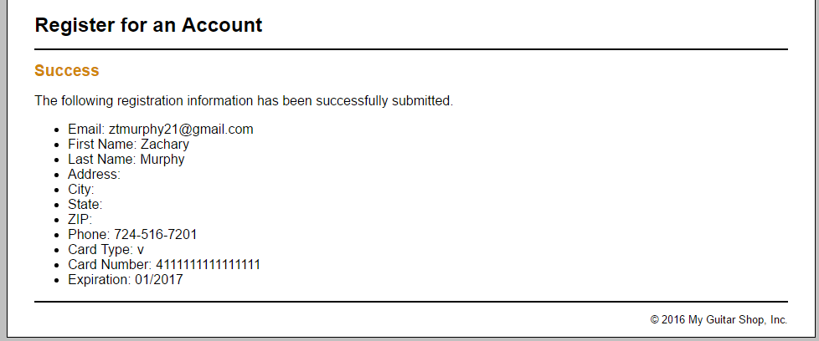

Allows the user to not need to enter address, city, state and zip.

**Ex 15-1 #7:**

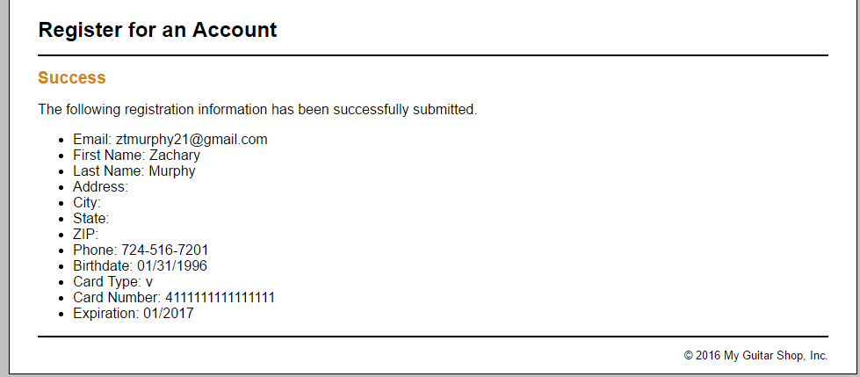

Added parts to code so the birthday function works. I noticed the book does not ask you to modify the success.php file, so there was no way for me to tell if it works.

**Ex 15-1 #8:**

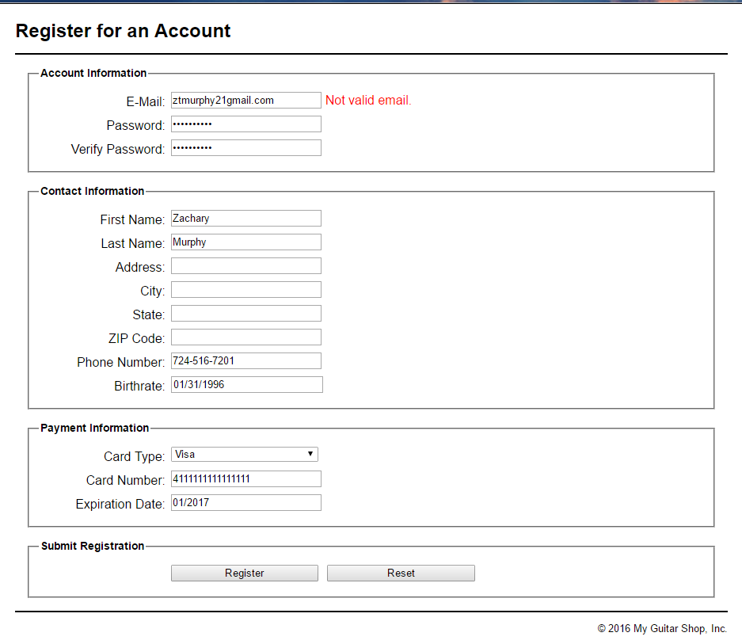

Changes to email function work to check for validity.

**Ex 15-2 # 1 & 2:**

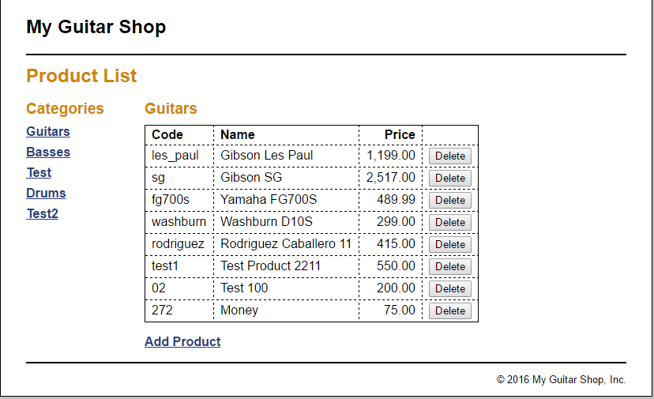

Ran and tested application.

**Ex 15-2 # 3 &4:**

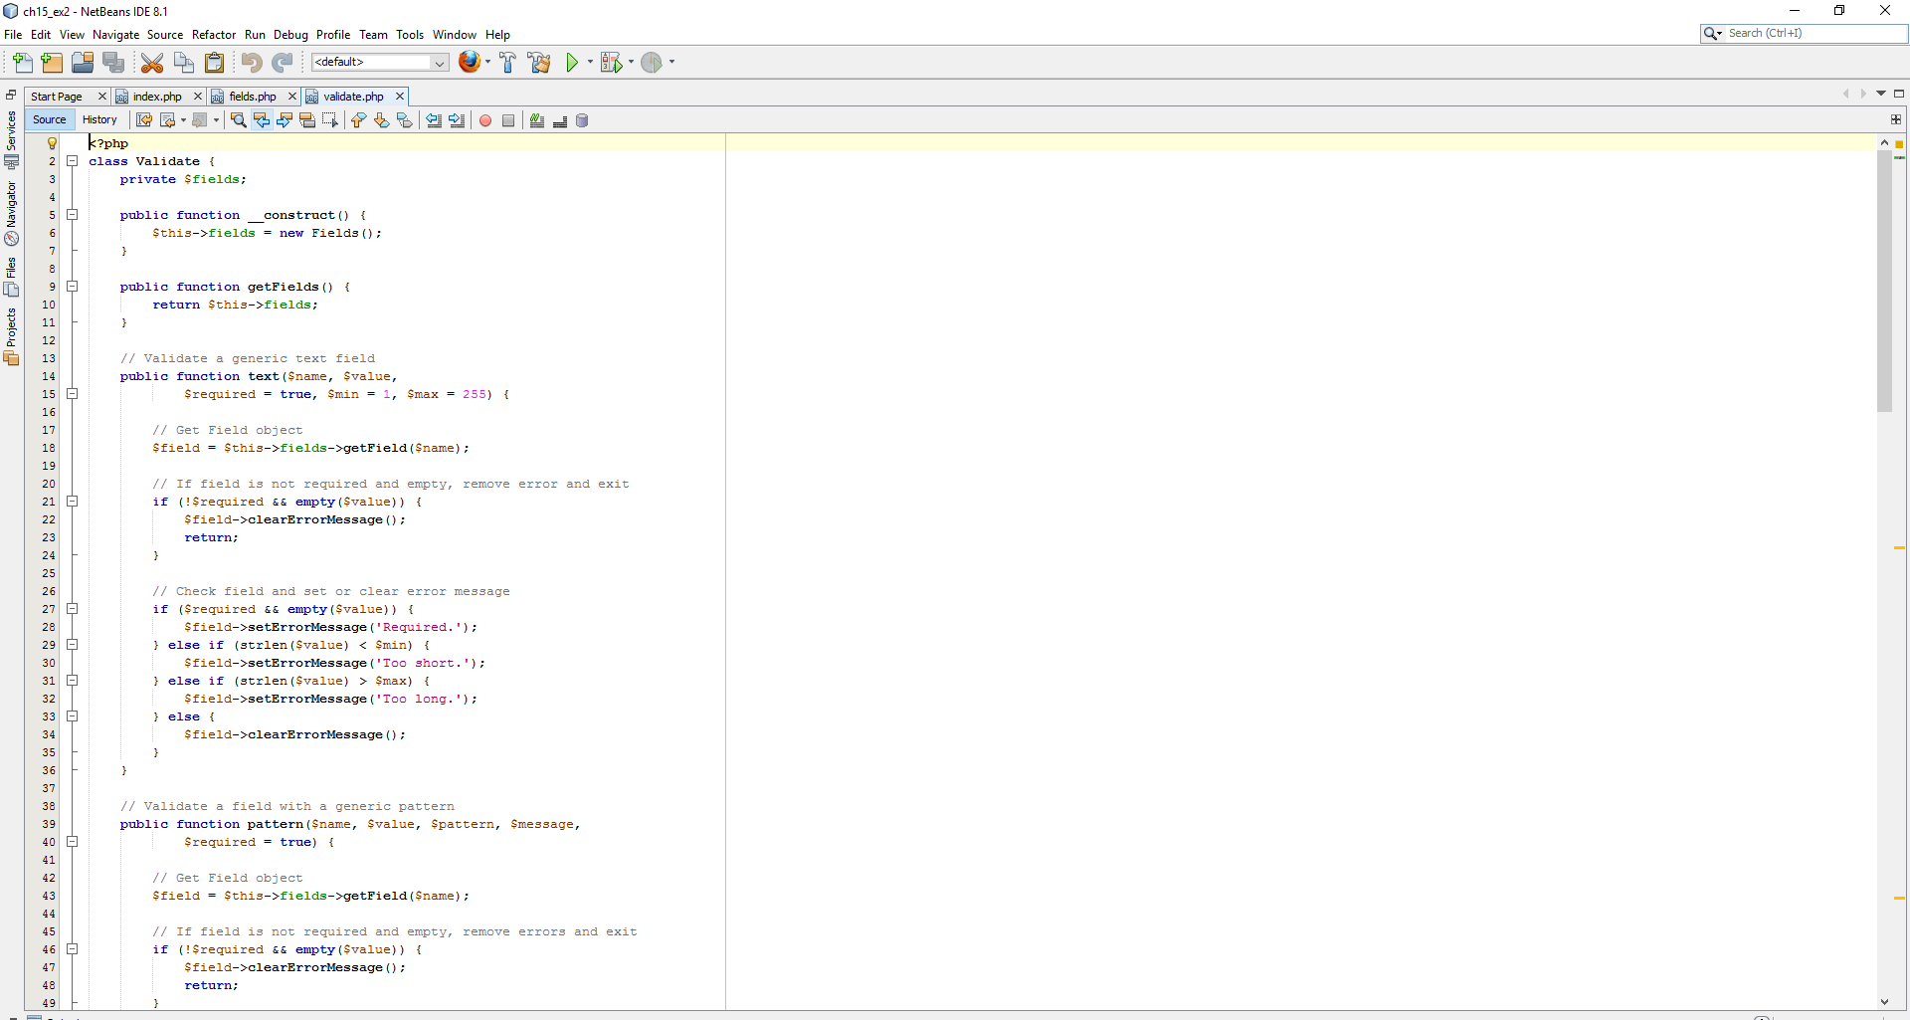

Opened all files needed as specified.

**Ex 15-2 #5-6:**

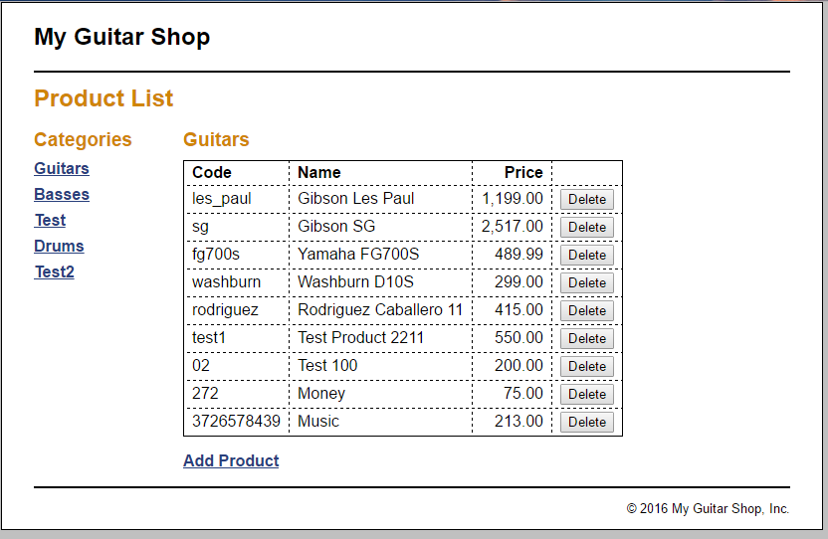

Changes work successfully.

**Ex 15-2 #7:**

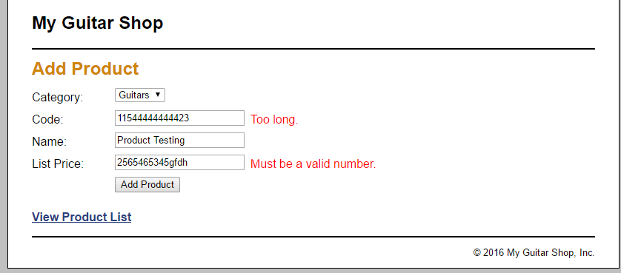

Checks for validation correctly.